Press Release
Thursday, December 15, 2016

Operation Granite Hammer

Immediate

The Goffstown Police Department, in conjunction with the Hillsborough County Sheriff’s Office Street Crimes Task Force, executed a search warrant at 602 Black Brook Road in Goffstown. Included with the search warrant were seven arrest warrants for individuals with various charges relating to the sale of heroin in the greater Goffstown Area. After a nearly four month long investigation regarding heroin sales and distribution, the following subjects were arrested today and charged with:

LOGAN JANAS, 29 Years Old, of Goffstown NH


SIX COUNTS OF SALES OF A CONTROLLED DRUG (HEROIN), All Class B Felonies

ADDITIONAL PENDING CHARGES INCLUDE:

SALES OF A CONTROLLED DRUG (HEROIN)
ENDANGERING THE WELFARE OF A CHILD
POSSESSION OF CONTROLLED DRUGS WITH THE INTENT TO DISTRIBUTE (HEROIN)
VIOLATION OF PROBATION/PAROLE
Logan was held on $100,000.00 Cash Only Bail and will be arraigned tomorrow (12/16/16) at the 9th Circuit District Court - Goffstown
AMY AUDETTE, 31 Years Old, of Goffstown NH

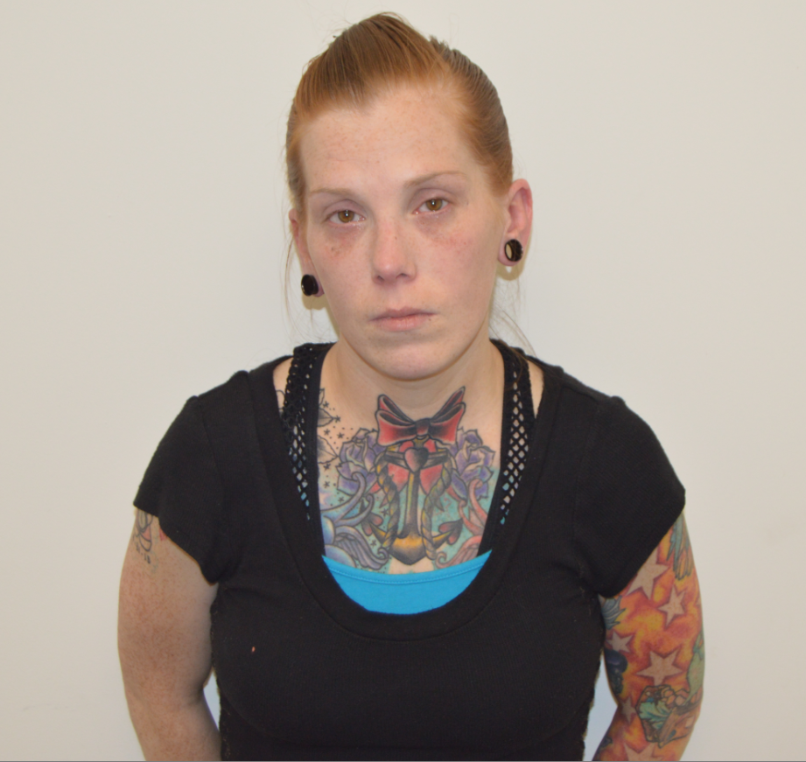

CRIMINAL LIABILITY FOR CONDUCT OF ANOTHER, Class B Felony

ADDITIONAL PENDING CHARGES INCLUDE:

ENDANGERING THE WELFARE OF A CHILD
CRIMINAL LIABILITY FOR CONDUCT OF ANOTHER

Amy was released on $5,000.00 Personal Recognizance Bail with a court date of January 5, 2017 at the 9th Circuit District Court – Goffstown.

PETER SAGE, 35 Years Old, of Manchester NH
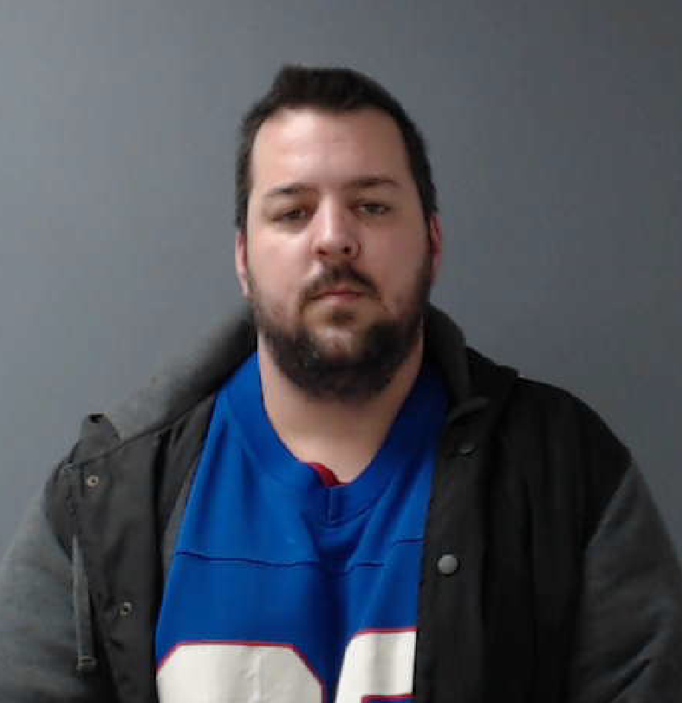

CRIMINAL LIABILITY FOR CONDUCT OF ANOTHER, Class B Felony
Peter was released on $5,000.00 Personal Recognizance Bail with a court date of January 5, 2017 at the 9th Circuit District Court-Goffstown

ROMAN RUSSELL, 30 Years Old, of Goffstown NH


CONSPIRACY TO COMMITT SALES OF A CONTROLLED DRUG, Class B Felony
Roman was released on $10,000.00 Personal Recognizance Bail with a court date of January 5, 2017 at the 9th Circuit District Court – Goffstown

GLENN JANAS, 68 Years Old, of Goffstown NH
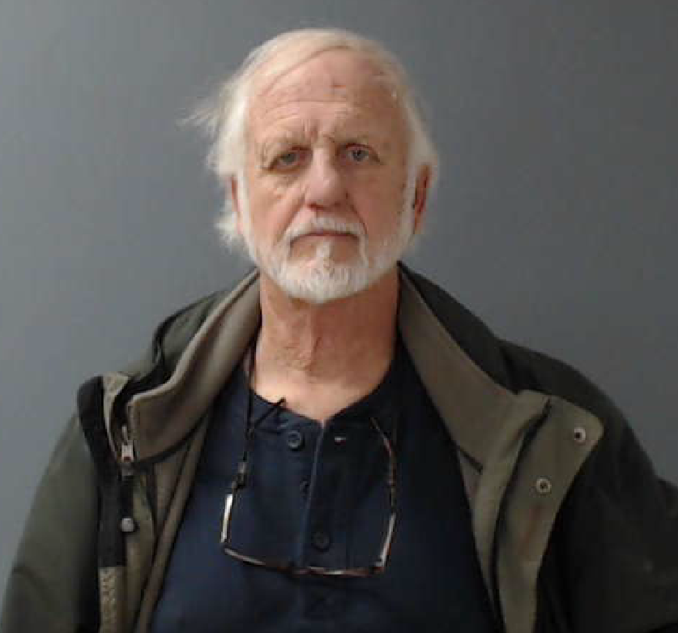

COMMON NUISANCE, Class B Felony
Mr. Janas was released on $1,500.00 Personal Recognizance Bail with a court date of January 5, 2017 at the 9th Circuit District Court – Goffstown.

MAUREEN JANAS, 65 Years Old, of Goffstown NH
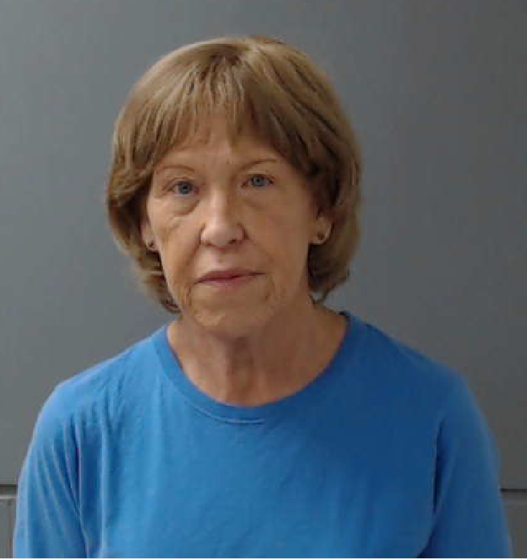

COMMON NUISANCE, Class B Felony
Mrs. Janas was released on $1,500.00 Personal Recognizance Bail with a court date of January 5, 2017 at the 9th Circuit District Court – Goffstown.

ANDREW CHAMBERLAIN, 29 Years Old, of Goffstown NH


SALES OF A CONTROLLED DRUG (HEROIN), Class B Felony
Andrew was released on $10,000.00 Personal Recognizance Bail with a court date of January 5, 2017 at the 9th Circuit District Court - Goffstown

